International Business

Student Name

Professor Name
Economics
30 November 2011

Introduction
The Daimler Corporation has been responsible for the manufacture of cars and trucks in Germany since the late 1800’s. The Daimler-Benz Corporation is famous for its flagship automobile the Mercedes Benz, recognized as a high end Executive car with a hallmark of quality German engineering. In May 1998 it was announced that the biggest merger of all time would take place between that of Daimler-Benz and the American car giant Chrysler Corporation. The objective being to make a global car manufacturing firm with the capability of delivering both luxury high end vehicles and cars suited for large-scale production in the mass market requirement. The $36 billion merger was heralded as the dawn of a new era. The Daimler head ‘Jurgen Schremp’ stated that it would become the world’s largest automobile manufacturer
From the outset the German manufacturer assumed control of the Organization and people referred to Chrysler being treated like a subsidiary rather than a partner of equals. Chrysler continued to remain unprofitable and the potential of having these two markets integrated appeared an impossible dream. The German manufacturer stated that the term of an equal partnership was purely stated to appease the American public but it was never going to be a reality. This subsequently resulted in a legal action being taken by billionaire shareholder Kirk Kerkorian who indicated that Daimler had misled the investors. Daimler subsequently settled the legal case for $300 million in the US Courts. By May 2007 Daimler was ready to sell off its 80.1% stake in the Chrysler Corporation. This was completed in August 2007 to the firm Cerberus Capital Management. Interestingly enough Cerberus got the Chrysler holding for only $7.4 billion, a huge drop from the $36 billion that Daimler originally paid for it. In essence Daimler paid over $650 million to dump Chrysler and it is reported to be one of the most expensive failed merger attempts in history. (McNamee 1998).
The changing automobile industry
The 1990’s witnessed a changing strategic and competitive shift in the environment of the automobile industry. Daimlers objective being the ability to build a more new stable agile business that will unlock the full potential of both companies. Zetche (CEO of the new business) further stated that the new firm will be centrally operated from Stuttgart in Germany consolidating Human Resources, Finance, Administration and as such save the new firm money. Early estimates predicted over 6,000 job cuts, including more than 50% in Germany. (Tierney, 2006)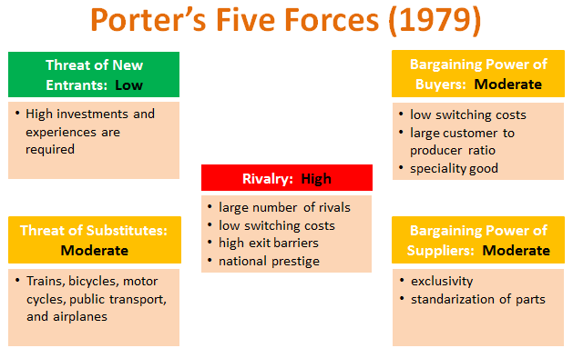
Porters 5 Forces model illustrates that Daimler felt very threatened by Rivalry within the marketplace and the encroachment of other automobile companies into its market space. The number of rivals had increased and it was starting to lose market share. Chrysler offered better market penetration in the mass car production market. The Daimler Benz boss Jurgen Schremp wanted to make Daimler-Benz a global power house and he saw the acquisition of Chrysler as a major step forward in that direction. His logic was based upon that this was a major US automobile manufacturer that had been very profitable in the early 1990’s. The firm specialised in mid-range cars and small trucks, an area where Daimler had no market penetration and in addition Chrysler had a great market success with its Jeep Grand Cherokee. Schremp was a good friend of Eaton (CEO at Chrysler) and he believed that the personal chemistry was right to achieve his global ambitions. Schremp referred to this as a ‘merger of equals’ referring more to the bold aggressive philosophical stance adopted by the Executive of both Companies. He later admitted however that it was always his intention for Daimler-Benz to retain control. (Schrempp 2011). (Schrempp, 2011)
Schrempp played a very clever move against the Chrysler Executive who failed to carry out proper due diligence in the merger. He persuaded the Management to Incorporate in Germany for Tax purposes i.e. DaimlerChrysler AG. They later discovered this meant the Company was governed by German laws and as such under German Incorporation it meant control was under German ruling that formed a minority on the governing board. This led the way to Schrempp taking control in 1999and ousting the Americans out of managerial control of the firm.
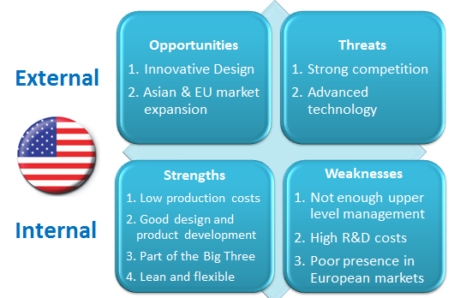| The strengths of Chrysler
Chrysler was viewed as an innovative Company that had creative designs and had market penetration in both Europe and South East Asia. It had low production costs and good engineering. . Its main threat was that of heavy competition from its rivals, particularly from Toyota. It had high research and development costs and did not perform well in European markets.
| The strengths of Daimler Benz
A reputation for producing high end, high quality premium cars that excelled in German technology and engineering. A strong market presence in Europe and other overseas countries. 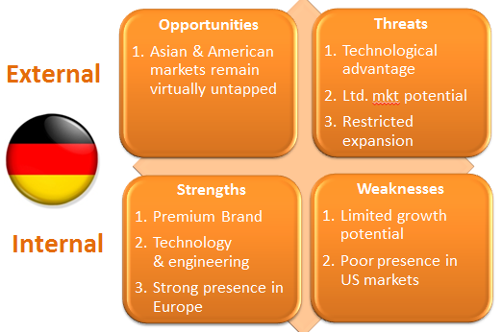It had not tapped into the lucrative Asian and American markets and this meant it was struggling from limited growth potential. It did not have adequate experience in the US market place.
Problems in managing the post-merger integration
In the management of the merger it is necessary to consider the main objectives from each organization.
| Daimler motive: To become a global player in the automobile market place leveraging off the strength of Chrysler in the mid-range vehicle market. To expand beyond its traditional European base into the US and Asian market place.
| Chrysler motive: To gain competitive edge in improved technology and engineering and overall improve quality to enable it to compete better in the market place. To expand beyond the North American market.
The combined merger bringing the ability to bring about higher manufacturing volumes whilst not forsaking quality. By pooling the combined knowledge it should enable increased global market penetration combing German Engineering with US Marketing skills. This to make it a global player in the automobile industry.
As such it is a symbiotic relationship with high organizational autonomy and high strategic independence.
The main failing of the Executive was in the management of the culture of the two companies. Instead of driving through competitive advantage the accelerated pace of the merger drove them both into a deeper crisis situation. There was an atmosphere of mis-trust and this resulted in many of the Chrysler Senior Executives leaving to join rival firms. Within the concept of a ‘merger of equals’ you would look at combining the best skills and cultures into a combined entity. Instead the merger more portrayed that of a hostile takeover and this resulted in increased rivalry between the two firms instead of creating synergy and working as a team towards common goals. (Hollman, 2010)
All of this made it harder to articulate the vision and manage the direction, it created a higher rate of good people leaving to rival firms, and it provided the competition with increased market leverage.
Lessons learned post-merger - Summary
Daimler Benz had reached its potential capacity in terms of producing luxury cars and the market would not sustain more than 1 million cars per year. Mercedes however wanted to increase its revenue base by 7% and penetrate international markets and it saw Chrysler as the ideal firm to penetrate the US and S.E. Asian markets in the mid-range car delivery service. Daimler never really wanted a partnership of equals but wanted to control Chrysler and build it in the same organizational framework of Daimler in Germany.
Equally Chrysler was running scared of a hostile take-over in the US market with the increased volatility. The CEO of Chrysler knew that the firm would not survive another financial crisis. He saw where Chrysler might benefit from Daimlers heritage and quality engineering skills. As such providing a valuable entry point to the mid-range European vehicle market. In many regards both had their eye on the prize without really giving sufficient thought to how two diverse cultures would fit together. Both firms were motivated by fear. With Daimler it was reaching capacity with no strategy to expand and the possible decline of the luxury car market in difficult financial times. With Chrysler it was the fear of a hostile takeover in the USA. Both CEO’s had their own different agenda’s but the Daimler CEO (Schrempp) deliberately misled the Chrysler investors in order to gain control over the merged company and oust the Chrysler management team. As such there was a level of mistrust and the Company never launched with a unified strategy that would harmonize the culture of the existing Companies into a new image with a unified management team.
As a result of Schrempps plots he plunged the new company into an immediate decline and he gained a terrible reputation in the USA as being one of the worst CEO’s on record. Despite this the shareholders of the new Company retained him in Germany. Daimler adopted a superiority complex towards Chrysler and thought of itself as the most advanced innovator in the automobile industry with a heritage of quality engineering.
A far cry from the mass produced assembly lines of the US automobile industry but the recognized the profits from producing inexpensive medium range cars that sell. Chrysler was a trendsetter in new innovative designs but lacked quality in its engineering processes. The firm had historically faced several bankruptcy situations and was seen as a mainstream rival to Ford and General Motors. None of the US cars were considered as status symbols for Executives who moved towards Mercedes and BMW.

Works Cited
Hollman, J. D. (2010). The Daimler Chrysler merger - A cultural mismatch. IFSM Santa Maria V3 No 3, 431-440.
McNamee, B. (2011, 11 9). Daimler Chrysler : A merger of equals? . Retrieved from CBC: http://archives.cbc.ca/version_print.asp?page-1&IDClip=16776&IDDossier
Schrempp, J. (2011). Reference for business. New York: Encyclopedia of Businress.
Tierney, C. a. (2006). Maximising the Merger. Detroit News.

