Research Proposal
What criteria should you consider when selecting a decision-making strategy?
Student Name
Professor Name
Management
22 August 2011

INTRODUCTION AND THEORETICAL FRAMEWORK
This research proposal addresses the concept of – what criteria should be considered when selecting a decision-making strategy. Decision Making is a vital component of all Managers and Executives responsibility. As such, it is vital to have the right strategy and approach for the business. In recent years, Kepner and Tregoe have introduced a widely adopted approach, as outlined in their book 'The New Rationale Manager'. There are also numerous other approaches and these are reviewed in this paper. Most of the study involves examination of grounded theory and the theoretical tenants that emerge from existing approaches to decision making. The qualitative research verifies the criteria for selecting a decision-making strategy (Borgatti, S.P. 1999)
STATEMENT OF THE PROBLEM
The paper addresses the most effective criteria to be used in selecting a decision-making strategy. What criteria are most appropriate in order to select the right strategic framework and approach? Complex decisions require an effective process in order to solve them. This requires a logical and systematic approach. The process has to be well defined in order to prevent poor decisions being reached that might have a profound adverse impact on a business organization. There are many variables at play and as such, it is essential to have well defined criteria for adopting the right strategic approach.
PURPOSE OF THE STUDY
The purpose of this research is to provide a qualitative assessment of the existing theoretical and method approach to effective decision-making models. In particular, evaluation of the key criteria that enables a manager to select the right method approaches within the more holistic strategic management decision-making framework. In addition, to gain a greater understanding of the different variables at play and how these might influence the selection criteria. The research will consider the adequacy of these theoretical models in the light of modern business practices and how well they have stood the test of time. Are the approaches still flexible enough to be adopted or re-aligned to modern business practices? How well do they relate to business transformation and conditions of change? (Ospina, S. 2004)

LITERATURE REVIEW
It is useful to gain an initial foundation of managerial decision making from an Economics viewpoint. This describes the foundation and needs for this approach in modern business.  The complexity of dynamic decision making in a modern business environment is explored by the researchers from York University in Canada.  Kepner and Tregoe provided one of the most enduring problem solving and decision making methods from their laboratories at Princeton University, NJ. This was updated in 1997 looking at the modern business perspective.  Allwood and Sellart examined the criteria for the selection of an effective decision making strategy. Their research goes towards understanding the complexity and approach. | Managerial Economics  By James R. McGuigan, R. Charles Moyer, Frederick H. deB Harris, 2008 Cengage Learning, New York. (McGuigan, J.R. 2008)  Complex decision making: theory and practice, By Hassan Qudrat-Ullah, J. Michael Spector, Pål I. Davidsen, 2010, Springer, New York (Qudrat-Ullah, H. 2010)  The new rational manager:  an updated edition for a new world, Charles Higgins Kepner, Benjamin B. Tregoe, Princeton Research Press, 1997 (Tregoe, B.B. 1997)  Decision making: social and creative dimensions, By Carl Martin Allwood, Marcus Selart, 2001 Kluwer Academic, Netherlands. (Allwood, C.M. 2001)

QUESTIONS AND / OR HYPOTHESIS
- What criterion exists for consideration in the selection of a decision making strategy?
- How does this criterion differ based upon the method or theoretical modelling approach selected?
- What distinguishes between the different criteria and are there any direct correlations that exist between the different types of decision making approaches
- What are the different qualitative aspects of the different criteria?
- How might the identifiable variables affect the selection of the decision-making criteria?
- Modernity – How flexible are the different theoretical models based upon current business practices with the advancement of technology and globalization?
- 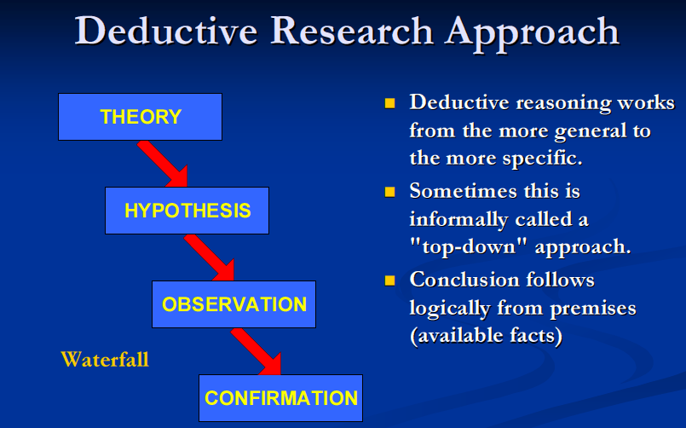Is there an identifiable relationship between that of external variables and the decision-making criterion used for selecting the right decision making strategy?
METHOD AND PROCEDURES
The research will employ a number of different approaches. The main theme however will be one of deductive research and this follows a standard waterfall type approach, as illustrated in the diagram to the right. An initial theory will be developed and this will be tested against the research questions or hypothesis. Appropriate observation and deductive analysis will be carried out and this will result in conclusions that will deny or validate the hypothesis or research questions. Original contribution will be through the examination of the external variables and the causative affect this has on the individual selection criteria for the decision-making models. Specific interest is focused upon the degree of correlation and alignment between these variables and the individual decision making models that are selected. (Jones, P.H. 2000)
Examples of decision-making criteria may include that of Uncertainty, Complexity, and Selection of Alternatives, High Risk impact or consequences, Interpersonal issues. This will require both a logical and systematic approach to decision-making that will need to cover such criterion as selection of the right environment, consideration of suitable alternatives, communications and method selection. (Mindtools, 2011)
DATA COLLECTION | The research data collected will comprise:
- Primary Research
- Secondary Research
- Use of Deductive Research
- Use of Empirical Research
- Qualitative assessments
The research to be carried out will be based upon the deductive research approach. This starts from general theoretical observations leading to the more specific. It is a waterfall based approach and sometimes referred to as “the top-down” approach. The conclusions will be based upon premises and evidential facts. (Knowledge Base Research, 2011)
This will involve examination of the problem statement in order to agree and reach an approved hypothesis. The strategy for carrying out the research will be based upon the construction of a theoretical framework and the development of a hypothesis. At this time both an alternate hypothesis and a null hypothesis will be developed. The subsequent information and data collection will then be analysed and interpreted in order to confirm or reject the produced hypothesis. The conclusions will then be developed based upon the research findings that either support or reject the hypothesis developed. Pilot work has not been identified at this time but a number of early concepts are in development stage.
RESEARCH TIMETABLE | Planned sequence of events
STAGE | RESEARCH ACTIVITY | ACTIVITY | ESTIMATED DURATION | OUTPUT
1 | Research Proposal |  | 1 Week | Research Proposal
2 | Research | Primary  Secondary  Literature Review | 1 Month  2 Months  1 Month | Research Composition
3 | Research | Conduct research  Analysis  Interpret results | 3 Months  3 Months  2 Months | Results of the Research
4 | Findings | Challenges  Write thesis | 1 Month  2 Months | Final Results and interpretation of research
5 | Final | Final Edits  Oral Defence | 2 Weeks  1 Day | Completion of Research

REQUIRED RESOURCES | Resources needed to complete research
- The following resources have been identified to support the research program
- University Library access | Librarian
- Research Assistant – Data Gathering
- Computer Technologist | Consultant
- Faculty Mentor | Guide over critical review points
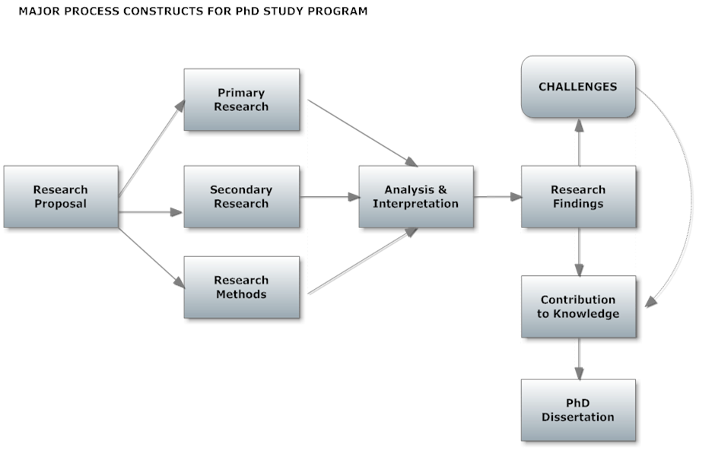RESEARCH DESIGN | Schematic of Research Design

ETHICAL CONSIDERATIONS
- Obtain required permissions on research and interviews
- Do not cause any harm to subjects
- Remain objective in research
- Keep findings confidential; inform those concerned where findings will be in public domain
- Ensure Ethics Review Committee approves work ; prior to commencement
- Keep gathered information factual

Works Cited
Allwood, C. M. (2001). Decision making: social and creative dimensions. Amsterdam, NL: Kluwer Academic.
Borgatti, S. P. (1999). Theoretical Framewoeks. Anon.
Jones, P. H. (2000). The Research Method. The Union Institute.
Knowledge Base Research. (2011). Deductive and Inductive Thinking. Retrieved 8 19, 2011, from Knowledge Base Research: http://www.socialresearchmethods.net/kb/dedind.php
McGuigan, J. (2008). Managerial Economics. New York: Cengage.
Mindtools. (2011). Decision Making Skills. Retrieved 8 21, 2011, from Mindtools: http://www.mindtools.com/pages/article/newTED_00.htm
Ospina, S. (2004). Qualitative Research. New York: Sage.
Qudrat-Ullah, H. (2010). Complex decision making theory and practice. New York: Springer.
Tregoe, C. K. (1997). The New rational Manager. Princeton NJ: Princeton Research Press.

